Department of Economics

Report for Academic Session 2022-23

- Report of “Research Workshop”

Date: 26 September, 2022

The society successfully organized the research workshop bifurcated into two sessions-” GETTING STARTED WITH RESEARCH” and “ACADEMIC WRITING”. The event was
held on 26 September, 2022 at 10:00 a.m. IST in the college auditorium. Almost 80 students and teachers actively participated in the Workshop. The fact that the event was a rewarding educational experience by reason of the consistent encouragement of our Respected Principal, Prof. Shiv Kumar Sahdev and much needed direction provided by our T.I.C Mr. Sumeet Singh Raheja and supporting faculty is no blanket statement.
The Workshop was led by Dr. Priyanka Arora, a visiting faculty at Ashoka University, outstanding in economic research. She has worked on the role of culture in the economy, its interactions with the economic sphere and the implications of these on economic development with a machiavellian touch of genius.

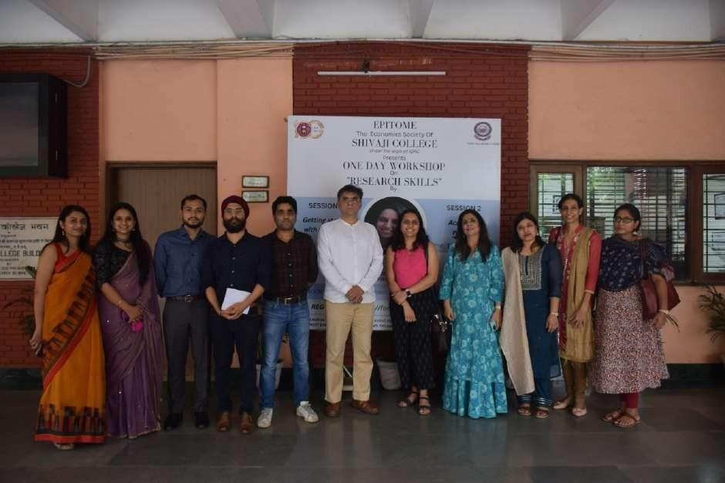
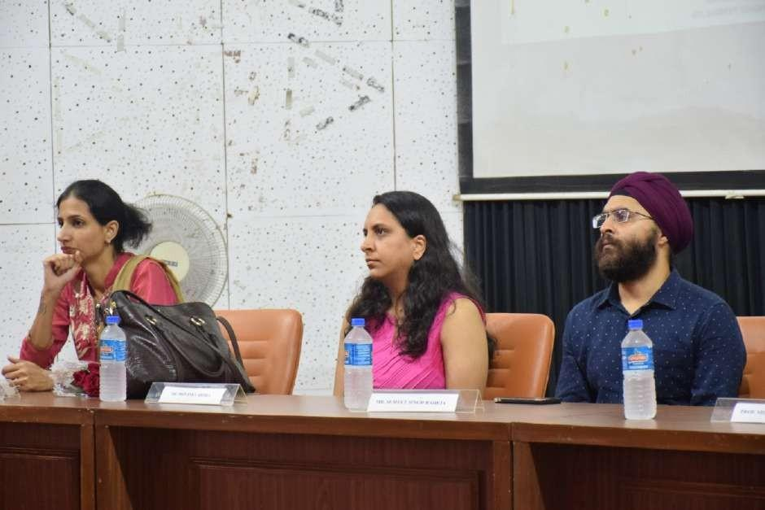

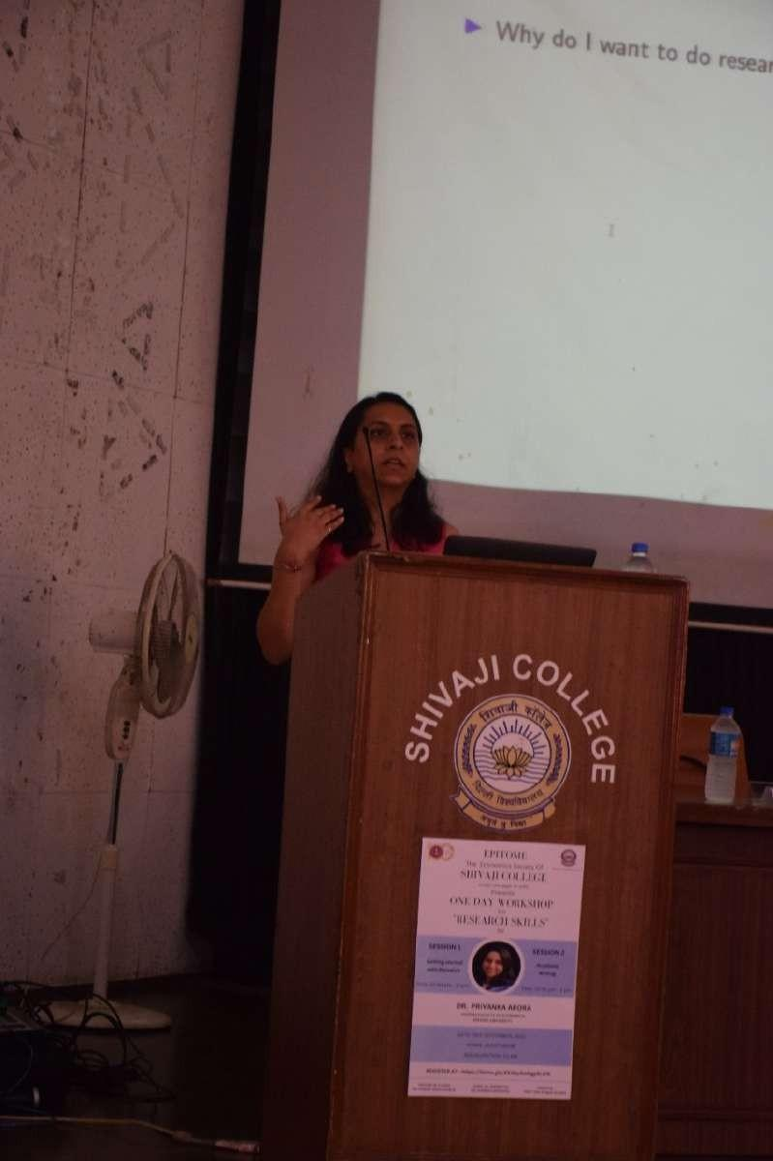

Report of Orientation Day by Department of Economics

Date: 2 November, 2022
The orientation event for was organized on 2 November, 2022 at 11 a.m. in room number 5 of college to address the incoming students. Around 32 first year students attended the programme where they were introduced to the faculty and the student council members.
The freshers were familiarized with the academic curriculum and department activities in the past and current initiatives being undertaken by the department to promote their learning and growth. The teacher-in-charge, Mr. Sumeet Singh Raheja discussed the timetable and course structure with the students. An announcement was also made to regularly check the college website for updates. Students were informed about the structure of new course under NEP.

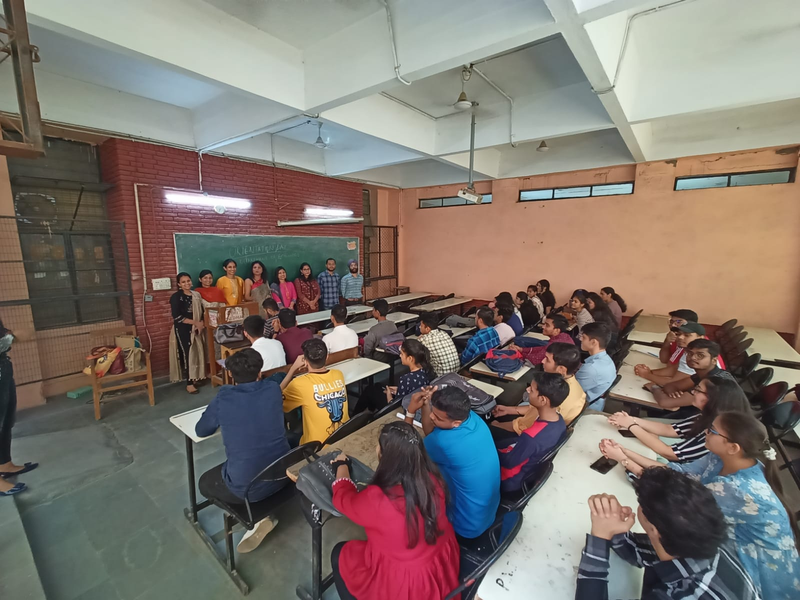

- Report on Seminar on “UPSC Examination: Insights on its Preparation

Date: 10 February, 2023

The core team of Epitome, together with students and faculty of the Economics Department triumphantly organized a seminar on the 10th of February 2023. The lecture was delivered by our speaker Mr. Raghvendra Sharma, who is an IPS 2021 batch and an alumnus of the Department of Economics of our college. The topic was "UPSC Examination: Insights on its Preparation" wherein he shared his journey of clearing the UPSC Examination along with some valuable tips for the current students.
The event began with auspicious lamp lighting seeking blessings, followed by the principal’s address to the audience. This was followed by the lecture attended by the student of economics department along with the students of various other departments like commerce, English, biochemistry, etc. He then answered questions from the students in the audience and addressed the queries eloquently.

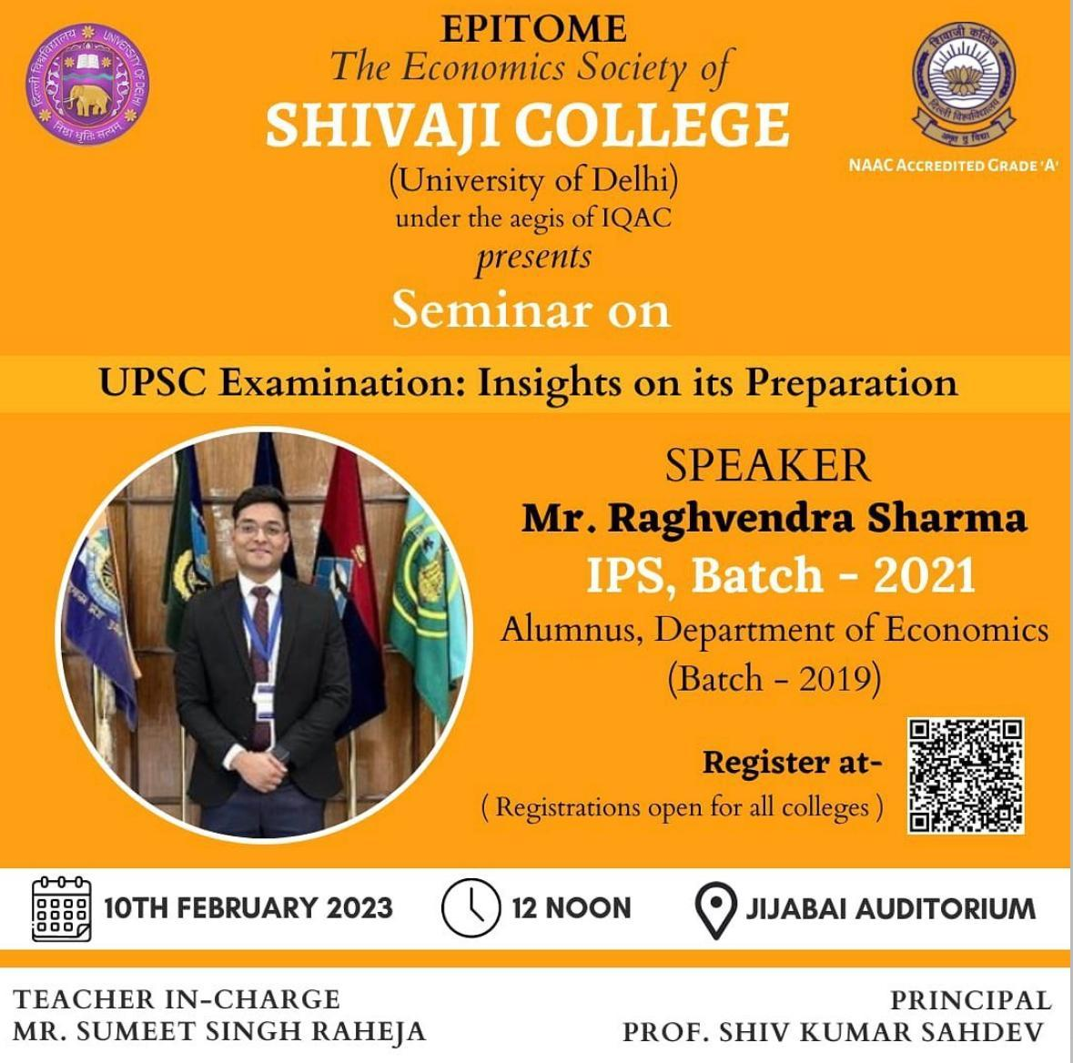

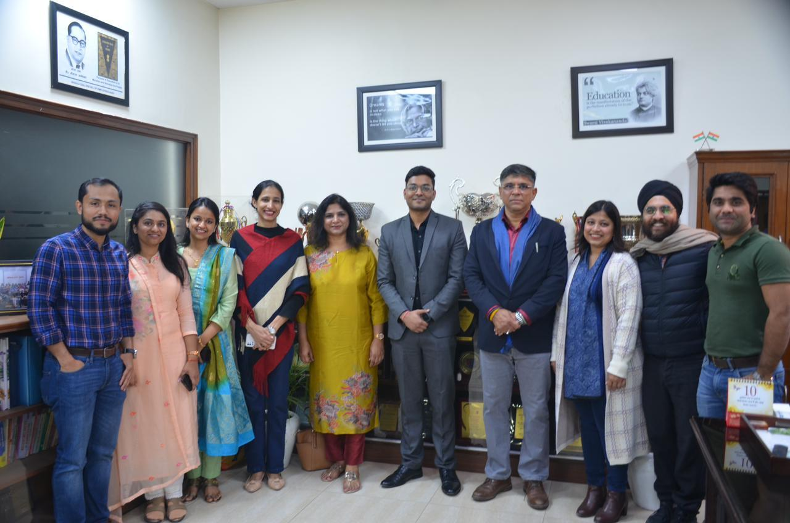

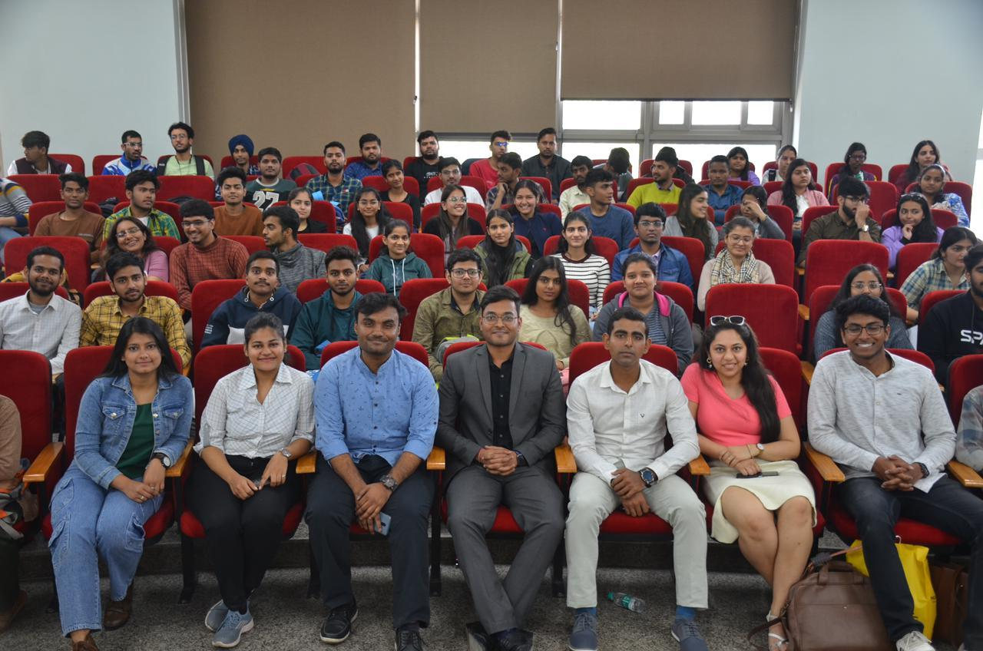
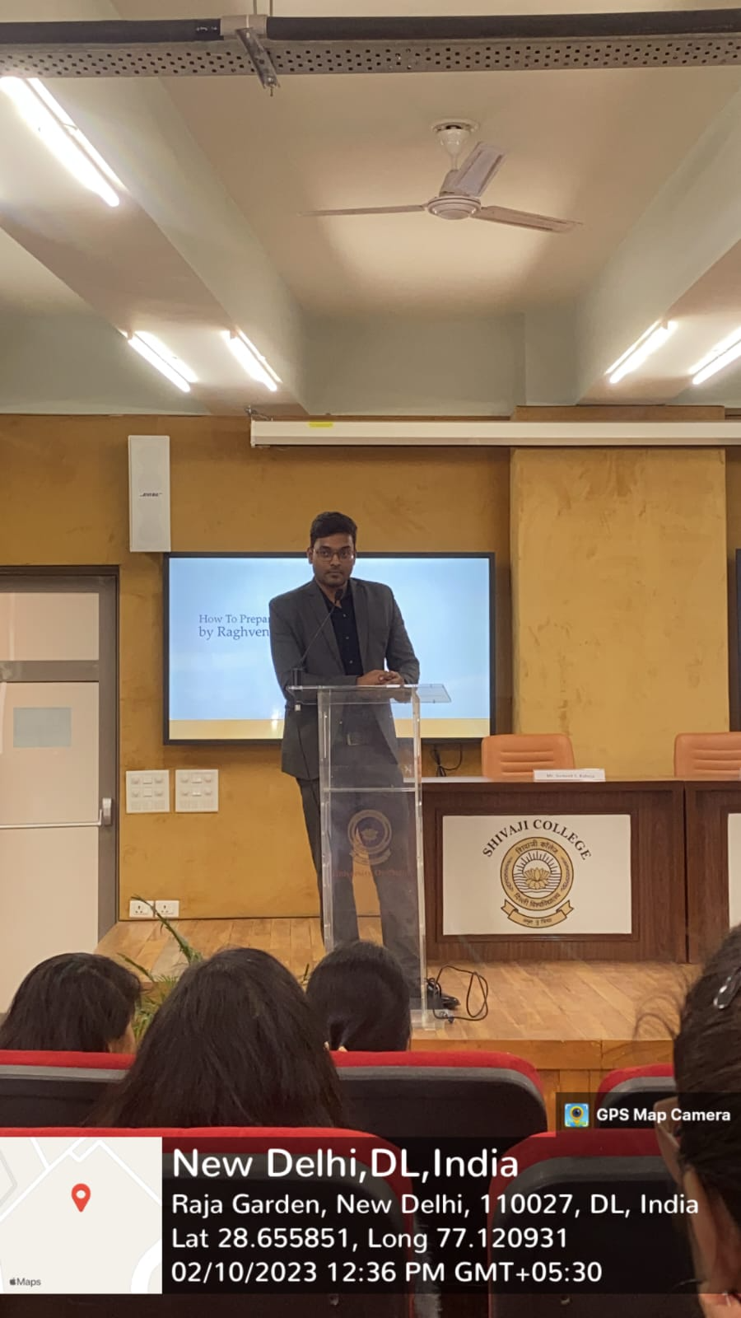

- Report of Economics Department Annual Festival - Pareto 2023
Date: 20 April, 2023

The Economics Department organized the annual fest, Pareto 2023 on the 20th of April 2023 with an attendance of more than 250 participants from across colleges.

The event began with a lecture delivered by the chief guest speaker, Prof. Sujoy Chakravarty, on the topic "Behavioural approaches to Development Economics". This was followed by the flagship event, 'Economist of the Year' had three rounds: The preliminary quiz tested participants based on their economic knowledge, the second round was the Policy Conclave, where the participants put forth their arguments on different economic policies and finally the third round, Econ Clueminati, a treasure hunt competition where the teams put their wit into practice and found clues to reach the ultimate solution.

Besides this, another academic event, 'The Case Crusade' – a case study competition where the teams presented their best solution to the given problem statements. The winning team and runner-up team were from Delhi Technological University and The Lady Shri Ram College, respectively.

