Department of Economics

Report for Academic Session 2021-22

Report of Webinar on “Role of State in Economic and Human Development” 2021

Date: 18 September, 2021
The event was virtually held on 18 September, 2021 at 6 p.m. IST via Zoom platform and was also streamed live on Youtube. Around 130 students and teachers actively participated in the webinar.

The Webinar was a walk through on the growing role of the state in enabling strong human development across various sectors such as health and education. It was led by Dr. Ajay Chibbar, distinguished Visiting Scholar, Institute for International Economic Policy, Elliott School of International Affairs, George Washington University and Non-Resident Senior Fellow at the Atlantic Council.

Outcome
- It made the students understand the structure and role of state versus markets in India.
- The students understood the impact of state interference in economic and human development and why markets are necessary wherever the government fails.
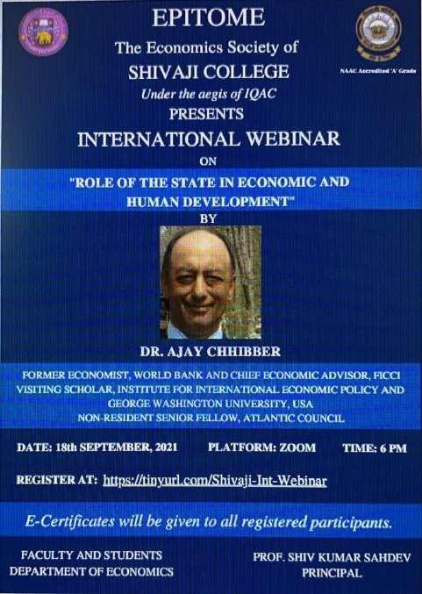
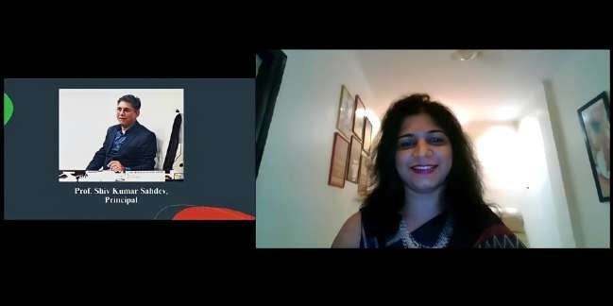

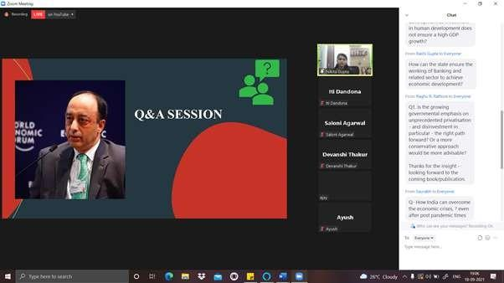

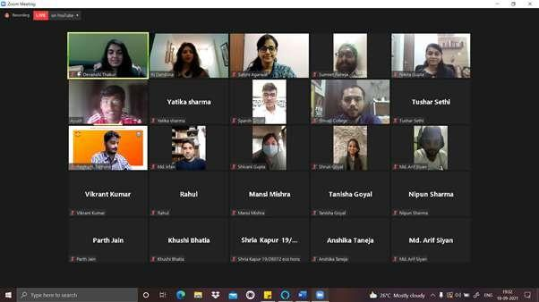

Report of Orientation Day by Department of Economics

Date: 18 November, 2021
The orientation event for was organized on 18th November, 2021 at 1 p.m. via Google Meet to address the incoming students. Around 56 first year students attended the programme where they were introduced to the faculty and the student council members.
The freshers were familiarized with the academic curriculum and department activities in the past and current initiatives being undertaken by the department to promote their learning and growth. The teacher-in-charge, Ms. Iti Dandona also discussed the timetable and course structure with the students. An announcement was also made to regularly check the college website for updates.

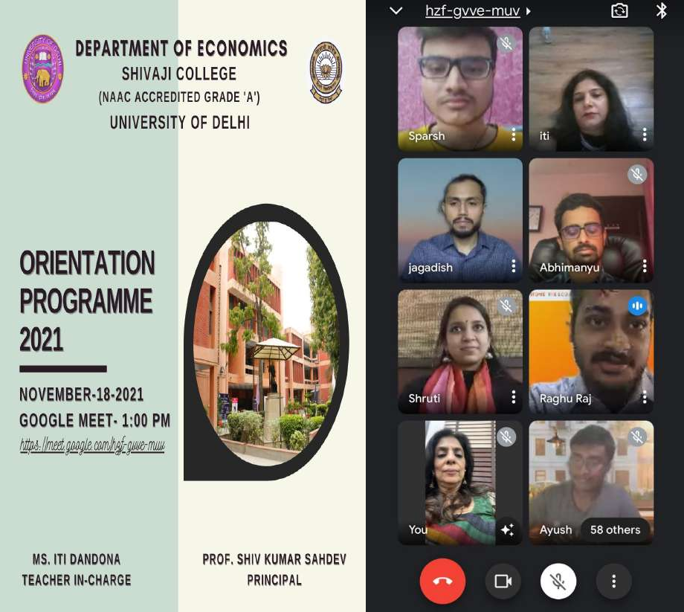

Report of Workshop on “OPEN DATA: WORLD BANK DATABASE’’

Date: 21 January, 2022
The event was virtually held on 21 January, 2022 at 12 pm IST via Zoom. Around 200 students and teachers actively participated in the Workshop. The Workshop was a demonstration on “how can one use the World Bank’s data resources efficiently and sharpen their analytical thinking and research skills”. It was led by Ms. Sunita Malhotra, having more than two decades of experience with World Bank in India, worked at American sectors and various NGOs.

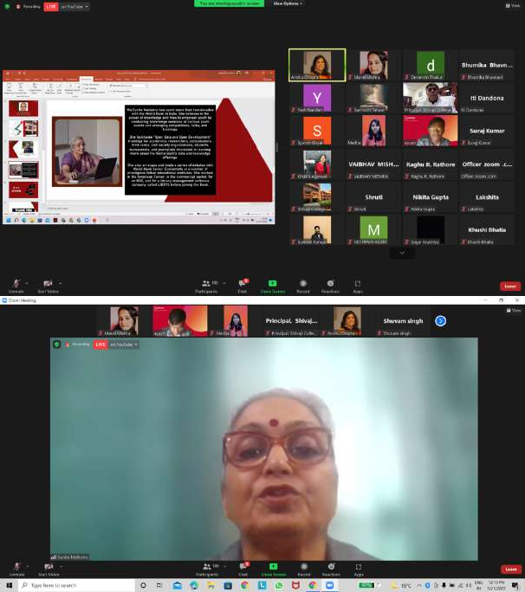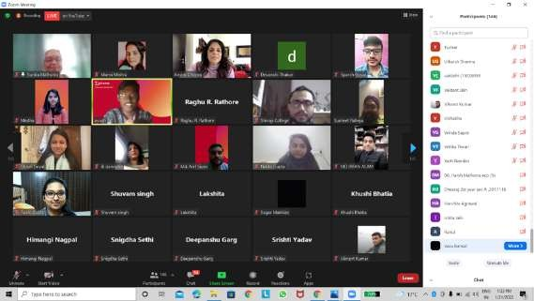

Report of Economics Department Annual Festival - Pareto 2022

Date: 8 April, 2022

The core team of Epitome, together with students and faculty of the Economics Department triumphantly organized the annual fest, Pareto 2022 on 8 April, 2022. The inter-college fest had an enthusiastic start with the inaugural session which took place in the auditorium in the college premises. About 250 students attended the event with students from different academic backgrounds like Business Economics, Mathematics, Political Sciences, and from different colleges in Delhi like VIPS, Satyawati, Aurobindo and many more.

This was followed by a lecture delivered by chief guest speaker, Dr. Abhijeet, on the topic "India’s Trade Policy: Opportunities, Obstacles and Options" wherein he spoke about the importance of international links and the potential and options for India in the field of international economics. The flagship event, 'Economist of the year' had three rounds : Preliminary Quiz, which was help online that tested participants based on their economic knowledge, the second round was Polemics, the debate competition where the participants were each stakeholders putting forth their arguments on different economic policies and events, and finally the third round, 'Case Competition', a case-study competition where the teams presented their best solution to the crisis they encountered with using economic principles and models, judged by faculty of the Economics Department. Team Social Capitalist, from college VIPS won the EOTY 22, followed by team Niti, from Aurobindo College and Satyawati College.

Besides this, a fun event, 'The Roast Battle' witnessed an overwhelming response of 40+ registrations, of which 4 teams were shortlisted. Teams roasted each other as spokesperson of another personality/brand they were allotted..
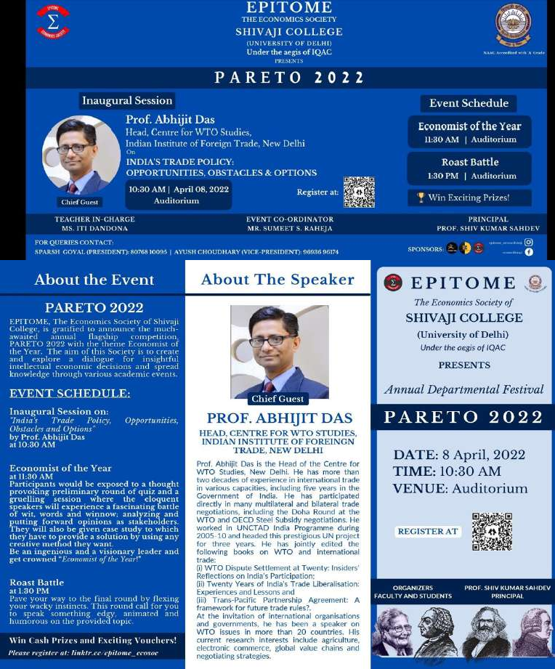
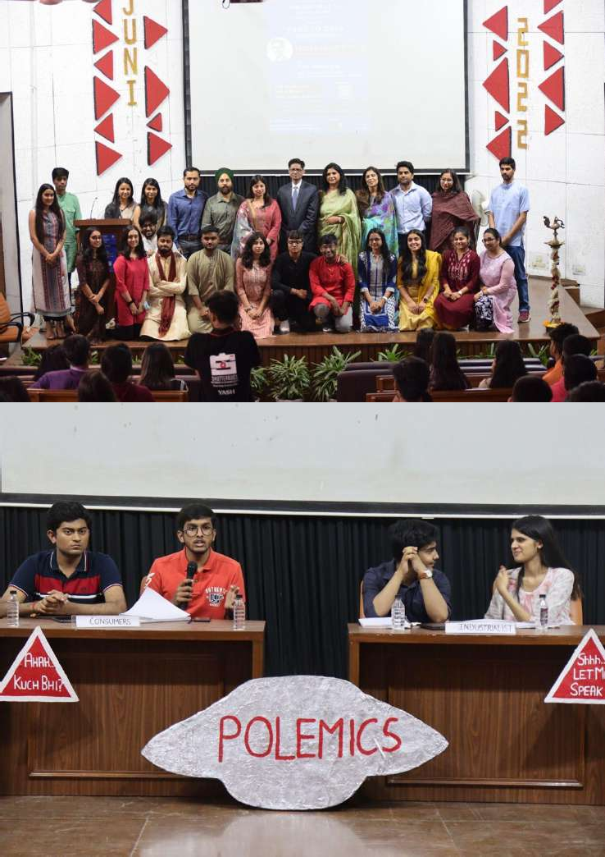

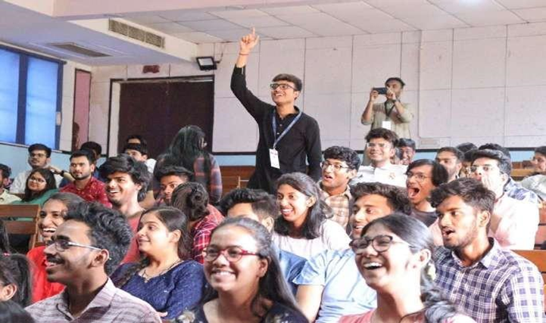

- Report of the Alumni Meet 2022

Date: 30 April, 2022

The virtual meet conducted on Zoom Platform started on 30th April 2022 at 4pm with a welcome address by Ms. Anshu Chopra, senior faculty and the teacher in-charge Ms. Iti Dandona and followed by the introduction of the faculty members and the office bearers for the session. The event further proceeded with some warm words by the teachers. The meet also saw the Alumni retracing their memory lanes through a special video prepared for them. After taking a trip down the memory lane the alumni had a fun time playing some virtual games planned by the team for them.

