13 Methods to Overcome Self-Incompatibility in Plants
Article Shared by <="" div="" style="margin: 0px; padding: 0px; border: 0px; outline: 0px; font-size: 16px; vertical-align: bottom; background: transparent; max-width: 100%;">
ADVERTISEMENTS:
The following points highlight thirteen methods to overcome self-incompatibility in plants. The methods are: 1. Bud Pollination 2. Mixed Pollination 3. Deferred Pollination 4. Test Tube Pollination 5. Stub Pollination 6. Intra-Ovarian Pollination 7. In Vitro Pollination 8. Use of Mentor Pollen 9. Elevated Temperature Treatment 10. Irradiation 11. Surgical Method 12. Application of Chemicals 13. Protoplast Fusion.

Method # 1. Bud Pollination:
It is the most successful method in both the gametophytic and sporophytic systems. The most advantageous stage for the buds to overcome self-incompatibility is two to seven days before anthesis. In Petunia axillares inhibition is nullified if the buds are self- pollinated two days before anthesis.
In the species at the bud stage the stigma lacks exudates, which appear only during anthesis. Thus if the stigma is self-pollinated at bud stage when the factor responsible for the exudates has not appeared, the pollen tubes will grow normally and effect fertilization.

Method # 2. Mixed Pollination:
ADVERTISEMENTS:
In this method the stigma is camouflaged from recognizing the incompatible pollen. This is achieved by pollinating the stigma with a mixture of chemically or irradiatedly treated compatible pollen, and live incompatible pollen.
It is presumed that when a stigma is pollinated with compatible pollen along with incompatible pollen, there the proteins released from the former facade the inhibition reaction at the surface of the stigma. Self-incompatibility has been overcome by using compatible pollen in Cosmos (sporophytic self-incompatibility) and Petunia hybrida (gametophytic self- incompatibility).

Method # 3. Deferred Pollination:
It has been observed that if pollination is deferred for few days, incompatible pollen tubes pass through the style. In Brassica and Lilium delayed pollination has been successful in overcoming self-incompatibility.

Method # 4. Test Tube Pollination:
Such a method to overcome self- incompatibility was first reported by Kanta (1962) in Papaver somniferum and later success also achieved in Argemone mexicana, and Eschscholzia californica of Papaveraceae and Nicotiana rustica and N. tabacum of Solanaceae.
ADVERTISEMENTS:
In this method, stigmatic, stylar, and ovary wall tissues are completely removed from the path of pollen tube. The bare ovules are directly dusted with pollen grains. Successfully pollinated ovules are cultured in a nutrient medium that supports germination as well as development of fertilized ovules into seeds.

Method # 5. Stub Pollination:
Those incompatibilities that are restricted to the stigma or to the length of the style that is larger than the maximum length attained by the pollen tubes have been overcome by removing the stigma and part of the style. The stigmatic surface of Ipomoea trichocarpa is the primary site of incompatibility and if the stigmatic lobe is removed and the cut surface pollinated then the pollen tube grows uninhibited in to the ovule.
Similarly it has been seen that crosses between Nicotiana tabacum x N. rustica and N. tabacum x N. debney fail, whereas their mutual crosses are successful. It is for the reason that in N. tabacum the style is longer than in the other two species, as a consequence the pollen tube fail to reach the ovule.
Following the removal of a large part of the style from N. tabacum and smearing the cut surface with agar-sucrose medium to function as a substrate followed by pollination with the pollen of N. rustica or N. debney, it was observed that in majority of the cases fertilization was successful.

Method # 6. Intra-Ovarian Pollination:
In cases where the zone of incompatibility lies in the stigma or in the style, there pollen suspension can be applied directly in the ovary to overcome incompatibility. Viable seeds have been obtained by this method in, Argemone mexicana and A. ochroleuca by Kanta and Maheshwari (1963).
In this method the ovary is at first surface sterilized, followed by injecting the aqueous pollen suspension (with or without specific substance for germination) by a hypodermic syringe followed by sealing the holes with petroleum jelly. The introduced pollen grains germinate and achieve fertilization. The method has also been successful in other members of Papaveraceae, like Papaver rhoeas and P. somniferum.

Method # 7. In Vitro Pollination:
This method was developed by Kanta (1962) in Papaver somniferum to overcome prezygotic barriers to fertility. The exposed ovules, achieved by removing the stigmatic, stylar, and ovary wall tissues were directly dusted with pollen grains and then cultured in a suitable nutrient medium that supported both the germination of pollen as well as the development of fertilized ovules. A better result is obtained by culturing the ovules within the intact placental tissue as such the technique is also termed as placental pollination.
Different forms of in vitro pollination have been proposed by Bhojwani and Razdan (1996):
a) Intraovarian pollination through a slit;
ADVERTISEMENTS:
b) Intraovarian pollination through a pore;
c) Stigmatic pollination where the pollens are placed on the stigma of a cultured pistil;
d) Placental pollination where pollens are dusted on the ovules which are cultured along with a piece of placental tissue;
e) Ovular pollination where individual ovules are cultured and pollinated.
ADVERTISEMENTS:
In self pollinated Petunia axillaris the pollen tube does not enter the ovary. This inhibition can be overcome by self-placental pollination. Viable embryos have been developed by such pollination in Petunia hybrida and Brassica campestris.
Several interspecific, intergeneric and interfamily crosses through placental pollination have been achieved in crosses between Melandrinm album x M. rubrum, M. album x Viscaria vulgaris, and M. album x Silene schafta.
Kranz and Lorz (1993) developed complete maize plant from in vitro formed zygotes obtained by fusing isolated gametes.
A brief summary of the in vitro fertilization in maize as described by Kranz and Dresselhaus (1996) is outlined below:
ADVERTISEMENTS:
i. In vitro fertilized eggs are cultured on a semi-permeable, transparent membrane (Millicell-CM dish) filled with 0.1 ml of nutrient medium.
ii. The dish is inserted at the middle of a 3 cm petridish with 1.5 ml nutrient medium that contains feeder cells obtained form embryogenic suspension cultures of another maize inbred line. The cultures are then incubated under 16 h photoperiod with 50pEnr² irradiance.
iii. The fertilized egg shows karyogamy within 1 h of fusion and 90% of the fusion products produce mini-colonies. In most cases a mini-colony grows into an embryo and ultimately into a fertile plant. (Fig: 6.17)
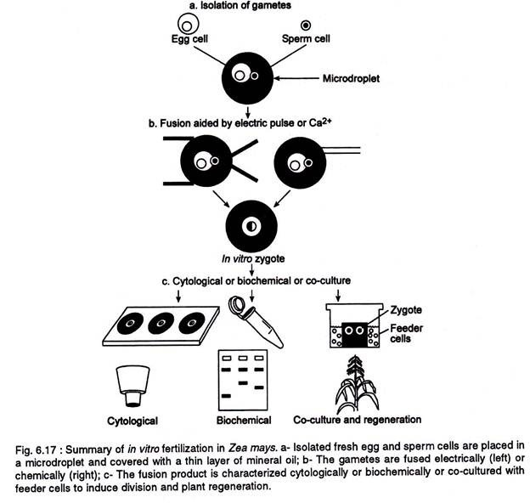

Method # 8. Use of Mentor Pollen:
Mentor pollen, (i.e. compatible pollen made ineffective by irradiation or repeated freezing and thawing or treating with chemicals like ethanol, for fertilization), has been used successfully to overcome incompatibility by using them along with live incompatible pollen. For instance in Cosmos mentor pollen as well their diffusates were effective in overcoming self incompatibility.
ADVERTISEMENTS:
Mentor pollen has been successfully used in Brassica oleracea, Petunia, Nicotiana, Lilium, and pear. The function of mentor pollen has been variously argued as providing recognition substances to incompatible pollen or to provide pollen growth substance which controls the production of pollen growth substances to incompatible pollen.
Stettler and Ager (1984) have suggested a possible mechanism to explain the effects of mentor pollen to overcome sporophytic incompatibility (e.g. Cosmos bipinnata, Theobroma cacao, etc.) and gametophytic incompatibility (e.g. Malus malus, Nicotiana alata, Petunia hybrida, etc.).
The mechanism i and ii, as shown in the Table 6.5 is based on experiments that demonstrates the effectiveness of mixing incompatible pollen with extracts of respective substances derived from compatible pollen.
The events at the stigmatic surface (i) is initiated by masking the inhibition reactions by the exine or intine held recognition proteins of compatible pollen, thus allowing the incompatible pollen to germinate and penetrate the stigma. Mechanism ii, considers n-hexane soluble compounds from exine to be more effective than the protein recognition method to overcome incompatibility.
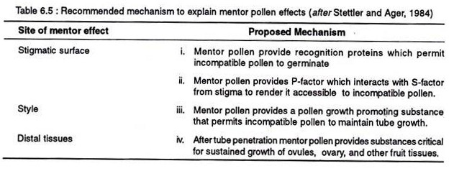
Mechanism iii, accounts for gametophytic self-incompatibility. The pollen growth promoting substances released from the exine or intine provide additional growth potential to the incompatible pollen tubes. In the mechanism iv, the mentor pollen indirectly acts in the smooth progress by way of contributing stimulatory signals for events related to fertilization and ultimately seed maturation.

Method # 9. Elevated Temperature Treatment:
Incompatibility reactions are affected by high temperature treatment. Hot water treatment of Lilium longiflorum detached or intact styles at 50 °C for 6 minutes before pollination help to overcome self-incompatibility. Temporary suppression of the incompatibility reactions was achieved in Oenotherafollowing the treatment of the style and stigma with hot water at 50 °C for 5 minutes.
Even in Secale cereale which has a very efficient incompatibility mechanism, even then a temperature of 30 °C is enough, to overcome self incompatibility reactions. In Trifolium increased in temperature decreased the self-incompatibility reactions.
Genetical studies indicate that sensitivity to temperature is due to a dominant gene marked as T-gene. Further, the stress generated by the daily variation in temperature has a positive effect in the strength of self-incompatibility.

Method # 10. Irradiation:
X-ray irradiation of flower buds at pollen mother cell stage helps to overcome self- incompatibility. In fact irradiation damages the physiological mechanism of self- incompatibility in the style, thus allowing the pollen tube to pass through the style.
Extensive work with induced mutation at the S-locus in Oenothera organensis and Prunus avium have been done by Lewis and Crowe (1953). They reported three types of mutations, viz., revertible mutation induces temporary inactivation of the S-allele thus enabling the pollen tube to pass through the style, however, self-incompatibility restored in the offspring.
Permanent mutation leads to inactivation of S- allele in the pollen only, whereas the allele remains fully functional in the style, as a result the pollen carrying the mutated allele (S_{A}) can grow on all styles, however, S_{A}-style will prevent the growth of a non-mutated S_{A} allele pollen. Irreversible stylar part mutation causes inactivation in the style only, however, the allele remains functional in the pollen and is inhibited in any other style carrying the same allele.
Centric fragment carrying a duplicated S- allele are seen in pollen-part mutants induced by irradiation in Petunia inflata and Nicotiana alata. Pollen-part mutation is the result of competitive interaction between the S-allele present on the chromosome and that on the centric fragment. This centric fragment is the complementation of the mutated S-allele. Irradiation of pollinia of Dendrobium with gamma rays is effective in inducing self- incompatibility.

Method # 11. Surgical Method:
The stigma becomes the zone of inhibition, in plants with sporophytic type of incompatibility. Thus in such cases removal of such barrier is effective in overcoming self- incompatibility. Defacement or decapitation of the stigma before pollination or deposition of pollen grains directly into the stylar tissue through a slit has helped in overcoming self- incompatibility.

Method # 12. Application of Chemicals:
Different chemicals including growth hormones have been recorded to be effective in overcoming self-incompatibility. Olivomycin and cycloheximide, the inhibitors of RNA and protein synthesis could overcome self- incompatibility in Petunia hybrida, when injected into the flower buds just 2-3 days before anthesis. The treatment of Brassica oleracea stigma before pollination with hexane was found to be effective in fruit set.
Hexane possibly inactivates the incompatibility factors on the stigma. Application of p-chloromercuribenzonate (5×10⁴ – 2x 10³M) also promoted pollen tube growth in the incompatible style of Oenothera organensis.
Success has also been reported by the application of growth hormones like, GA₃, indole butyric acid, NAA, etc. in Petunia, Tagetes, Trifolium, Brassica, Lilium, and Lycopersicon. It is believed that these growth hormones by inhibiting floral abscission allow the slow growing pollen to reach the ovary. Benzylaminopurine is most effective in inducing selfed seed-set in the self-incompatible Lilium.

Method # 13. Protoplast Fusion:
In cases where sexual incompatibility does not permit to raise hybrids by the conventional methods, there the fusion of isolated protoplasts have achieved great success. Since it involves the fusion of somatic protoplast, the method is described as parasexual hybridization.
The technique involves three basic steps, viz., isolation of protoplasts, fusion of the isolated protoplasts, and culture of hybrid protoplast to regenerate whole plants.

References:
https://www.slideshare.net/manasicar/self-incompatibility-ppt

